WARRANTY INFO:

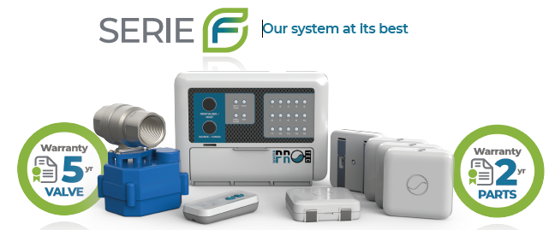

Choose extra warranty coverage for a fee. There is the option of a 1-year labour warranty which includes preventive maintenance and 24/7 technical help.

**Note all are ETL tested and meet the CSA standards and conform to UL Standards.

